PROJECT REPORT
ON
“School Time-Web Based Automatic Timetable Generator”

Submitted in partial fulfilment of the
requirement for the award of the degree of
Bachelor of Computer Applications
to
Uttaranchal School of Computing Sciences


SESSION (2025-26)

Submitted To: Submitted By:
Ms. Rashmi Kuksal Anchal Rana
Assistant Professor BCA 4th “D”
USCS Enrolment No:
UU2409000038

ACKNOWLEDGEMENT

The most awaited moment of any endeavour is its successful completion, but nothing can be done successfully if done alone. Success is the outcome of continuous technical mentoring, guidance, and support from various individuals, and I express my sincere gratitude to all those who contributed to the successful completion of this project.
First and foremost, I would like to thank Prof. (Dr.) Sonal Sharma, Director, USCS, for providing a healthy and encouraging environment for study.
I am extremely thankful to Prof. (Dr.) Sameer Dev Sharma, Head of Department, USCS, and my project mentor Ms. Rashmi Kuksal, for providing me with this opportunity and for their valuable technical mentorship, continuous guidance, and expert insights throughout the project development process. Their support at every stage significantly enhanced my understanding and helped me successfully complete this work.
I also express my sincere gratitude to my colleagues for their valuable discussions and support, which helped me in giving a final shape to this project

Date:
Anchal Rana
UU2409000038
BCA 4th -D

DECLARATION

I hereby declare that the project titled “School Time-Web Based Automatic Timetable Generator” is an original work carried out by me under the guidance of Ms. Rashmi Kuksal in partial fulfilment of the requirements for the award of the degree of BCA from Uttaranchal University.
I further declare that this project has not been submitted, either in part or in full, to any other institution or university for the award of any degree or diploma.
All sources of information and references used in this project have been duly acknowledged.

Date:
Anchal Rana
UU2409000038
BCA 4th -D

Uttaranchal School of Computing Sciences

CERTIFICATE

This is to certify that the project work entitled “School Time-Web Based Automatic Timetable Generator” is a Bonafide work carried out by Anchal Rana (UU2409000038) submitted in partial fulfilment for the award of the degree in Bachelor of Computer Applications (BCA) of Uttaranchal University, Dehradun during the academic year 2025-26.

Ms. Rashmi Kuksal
Assistant Professor
USCS

CONTENTS
ACKNOWLEDGEMENT ii
DECLARATION iii
CERTIFICATE iv
INTRODUCTION 1
OBJECTIVE 2
SYSTEM ANALYSIS 3
IDENTIFICATION OF NEEDS 5
PRELIMINARY INVESTIGATION 6
FEASIBILITY STUDY 8
PROJECT PLANNING 9
SOFTWARTE REQUIREMENT SPECIFICATION (SRS) 11
SOFTWARE ENGINEERING PARADIAGRM APPLIED 13
DFD (DATA FLOW DIAGRAM) 15
GANTT CHART 16
PERT CHART 16
CONTROL FLOW DIAGRAM (CFD) 17
FLOWCHART 18
SYSTEM DESIGN 19
TESTING 21
SYSTEM SECURITY MEASURES 24
FUTURE SCOPE AND ENHANCEMENTS 25
CODE 27
SNAPSHOTS 63
BIBLIOGRAPHY 68

INTRODUCTION

In today’s modern academic environment, managing timetables in schools, colleges, and universities has become a challenging task. Timetable preparation is an important administrative activity that involves arranging subjects, teachers, classrooms, and time slots in a proper and systematic way so that academic activities run smoothly. Traditionally, this process is done manually by administrators, which takes a lot of time and effort.
Manual timetable creation is not only time-consuming but also very complex. It requires careful handling of many factors such as teacher availability, subject requirements, classroom allocation, and equal distribution of workload among teachers. Because of these multiple constraints, manual scheduling often leads to common problems like class clashes, double booking of teachers or rooms, and uneven workload distribution. It also requires frequent changes, which makes the process even more difficult and inefficient.
To solve these issues, many automated timetable generation systems have been developed in recent years. Tools like Timetable Master, aSc Timetables, and Untis provide advanced features such as automatic scheduling and conflict management. However, most of these tools are commercial software that require paid licenses, proper technical setup, and trained users. This makes them less suitable for small institutions or student-level projects.
The Automatic Timetable Generator is proposed as a simple, efficient, and cost-effective solution to overcome these challenges. This system automates the entire timetable creation process by using input data such as teacher details, subject requirements, and available time slots. It ensures that no scheduling conflicts occur and that all resources are used efficiently.
The system uses an intelligent scheduling approach, such as a Greedy Algorithm, to assign teachers to classes based on their current workload. This helps in maintaining a balanced timetable where no teacher is overburdened, and all classes are scheduled properly. Additionally, the system ensures proper classroom allocation and avoids overlapping of lectures.
The project is developed as a web-based system using Python for backend processing and MySQL for data storage, along with HTML for the user interface. This makes the system easy to use, accessible from any browser, and suitable for institutions of different sizes.

OBJECTIVE

- Automate Timetable Creation: To automatically generate class timetables and reduce manual scheduling.
- Prevent Scheduling Conflicts: To ensure that teachers and classrooms are not assigned to multiple classes at the same time.
- Balance Teacher Workload: To distribute teaching periods fairly among teachers.
- Improve Efficiency: To reduce time and effort required for timetable preparation.
- Generate Organized Timetable: To produce a clear and structured timetable for easy use by teachers and students.

SYSTEM ANALYSIS

System analysis is the crucial phase in development of system project. It ensures that tools meet the requirement for security, usability, and functionality also helps in planning the databases’ structure, user interfaces and security measures.
PROBLEM STATEMENT
Timetable preparation in educational institutions is a complex and time-consuming task when done manually. It involves managing multiple constraints such as teacher availability, subject allocation, classroom usage, and balanced workload. Manual scheduling often leads to conflicts, overlapping classes, and inefficient use of resources. Existing automated systems are mostly costly and require technical expertise, making them unsuitable for smaller institutions. Therefore, there is a need for a simple and efficient system that can automatically generate a conflict-free timetable while reducing manual effort and errors.
SYSTEM REQUIREMENT
- Hardware
  - Processor: Intel Core i3 or higher
  - RAM: Minimum 4 GB
  - Storage: At least 20 GB free disk space
  - Input Devices: Keyboard and Mouse
  - Output Device: Monitor
- Software
  - Operating System: Windows / Linux / macOS
  - Programming Language: Python
  - Framework: Flask
  - Frontend Technologies: HTML, CSS
  - Database: MySQL
  - Development Tools: VS Code
  - Web Browser: Google Chrome / Firefox
- Tools Used
  - Draw.io – For diagrams and system design
  - MySQL Workbench – For database management
  - Browser Developer Tools – For debugging and testing

FUNCTIONAL REQUIREMNETS
▪ User Management:
  - Admin login and authentication.
  - Role-based access control (only admin can manage timetable).
- Data Management:
- Add, edit, and delete teacher details.
- Add, edit, and delete subjects and classrooms.
- Manage available time slots.
- Timetable Generation:
  - Automatically generate timetable.
  - Assign subjects, teachers, and classrooms.
  - Use algorithm to ensure efficient scheduling.
- Conflict Management:
  - Prevent overlapping of teachers, classrooms, and subjects.
  - Ensure conflict-free timetable generation.
- Workload Management:
  - Distribute workload evenly among teachers.
  - Avoid overloading or underloading of teachers.
- Timetable Display:
  - View generated timetable in a structured format.
  - Allow updates or modifications if required
NON-FUNCTIONAL REQUIREMENTS
- Performance:
  - Fast timetable generation.
  - Efficient handling of large data.
- Usability:
  - Simple and user-friendly interface.
  - Easy navigation for admin.
- Reliability:
  - Accurate and consistent timetable generation.
  - Minimal errors in scheduling.
- Security:
  - Secure login system.
  - Restricted access to authorized users only.
- Scalability:
  - Able to handle increasing number of users and data.
- Maintainability:
  - Easy to update and improve the system.
- Compatibility:
  - Works on different browsers and devices.

IDENTIFICATION OF NEEDS

The management of academic timetables is a complex task that often leads to conflicts and inefficiencies when done manually. With increasing academic requirements, manual scheduling becomes time-consuming and error prone. This creates the need for an Automatic Timetable Generator to produce accurate, conflict-free schedules efficiently.
Some of the existing problems are:
- Need for Automation:
• Manual timetable creation is time-consuming and complex.
• Automation reduces human effort and saves time.

- Need to Avoid Conflicts:
• Manual scheduling often causes clashes of teachers, classrooms, and subjects.
• A system is needed to generate conflict-free timetables.

- Need for Efficient Resource Utilization:
• Proper use of teachers and classrooms is required.
• The system ensures no resource is overused or left unused.

- Need for Balanced Workload:
• Teachers should have equal and fair distribution of classes.
• The system helps in maintaining workload balance.

- Need for Accuracy:
• Manual methods are prone to errors.
• An automated system improves accuracy and reliability.

- Need for Cost-Effective Solution:
• Existing software is expensive and requires technical setup.
• A simple system is needed for small institutions and projects.

- Need for Easy Access and Management:
• Administrators need a simple interface to manage timetables.
• A web-based system allows easy access and updates.

PRELIMINARY INVESTIGATION
- CURRENT SCENARIO

  - Many institutions still prepare timetables manually or using basic tools.
  - Scheduling is done without proper automation, leading to frequent adjustments
  - Teacher availability, classroom allocation, and subject distribution are managed manually.
  - Data management is not well-organized, especially in small institutions. Limited use of intelligent algorithms for scheduling.
  - Lack of real-time updates and quick modifications. Communication of timetable changes to students and staff is slow.

- DRAWBACKS OF CURRENT SCENARIO

  - Time-consuming and requires high manual effort.
  - High chances of errors and scheduling conflicts.
  - Difficult to manage large numbers of teachers and classes.
  - Unequal workload distribution among teachers.
  - Frequent changes make the process inefficient.
  - Lack of proper data storage and record management

- PROBLEM IDENTIFIED

  - Scheduling Conflicts: Clashes of teachers, classrooms, and subjects at the same time.
  - Complex Constraint Handling: Difficulty in managing teacher availability, subject requirements, and time slots together.
  - Uneven Workload Distribution: Some teachers get more classes while others get fewer.
  - Time-Consuming Process: Manual timetable creation takes a lot of time and effort.
  - Frequent Modifications: Changes are required again, reducing efficiency.
  - Human Errors: High chances of mistakes in manual scheduling.
  - Lack of Suitable Systems: Existing tools are costly and not suitable for small institutions.

- PROPOSED SOLUTION

The Automatic Timetable Generator is proposed as an efficient system that will:
  - Automatically generate a conflict-free timetable.
  - Assign teachers, subjects, and classrooms efficiently.
  - Ensure balanced workload distribution among teachers.
  - Store timetable data in a structured database.
  - Reduce manual effort and errors.

- BENEFITS OF PROPOSED SYSTEM

  - Efficiency: Saves time and reduces manual work.
  - Accuracy: Generates error-free timetables.
  - Fairness: Ensures equal workload distribution.
  - Reliability: Provides organized and easily accessible data.

FEASIBILITY STUDY

A feasibility study is conducted to determine whether the proposed Automatic Timetable Generator is practical, achievable, and beneficial to develop. It evaluates technical, operational, economic, and time aspects to ensure successful implementation.
1. Technical Feasibility
- The system will be developed using widely available technologies like Python, MySQL, and HTML.
- Database systems will be used to store teacher, subject, classroom, and timetable data.
- Scheduling algorithms (e.g., Greedy Algorithm) can be implemented easily using existing programming techniques.
- No advanced or costly technical infrastructure is required.
2. Operational Feasibility
- The system provides a simple and user-friendly interface for administrators.
- It can be easily integrated into existing academic processes.
- Reduces manual effort and simplifies timetable management.
- Users can quickly adapt as it automates complex scheduling tasks.
3. Economic Feasibility
- Development cost is low as it uses open-source tools and technologies.
- No need for additional hardware; it can run on existing systems.
- Reduces administrative workload, saving time and cost in the long run.
- More affordable compared to commercial timetable software.
4. Time Feasibility
- The system can be developed within a limited time suitable for academic projects.
- Core features like data input and timetable generation can be completed first.
- Additional features can be added later due to modular design.

PROJECT PLANNING

Project planning is one of the most important phases of software development. It defines the scope, identifies tasks, allocates resources, and sets timelines for successful completion. For the Automatic Timetable Generator, project planning is carried out systematically to ensure efficient development and to achieve the objective of generating a conflict-free and well-structured timetable.
- Project Scope

- The scope of this project includes:
- Development of a system to automatically generate timetables.
- Input and management of teacher, subject, classroom, and time slot data.
- Implementation of scheduling algorithms to avoid conflicts.
- Balanced distribution of workload among teachers.
- Storage and retrieval of timetable data using a database (MySQL).
The project does not initially focus on advanced features like AI-based scheduling, mobile applications, or multi-institution integration, but provides a base for future enhancements.
- Project Phases

- Requirement Analysis: Collecting system requirements and understanding constraints.
- System Design: Creating DFDs, ER diagrams, flowcharts, and system architecture.
- Implementation (Coding): Developing frontend (HTML/CSS) and backend (Python/Flask).
- Testing: Performing unit testing and system testing to ensure accuracy.
- Deployment: Running the system in the target environment.
- Maintenance: Fixing errors and improving the system when needed.

- Task Scheduling

  - Week 1–2: Requirement gathering and planning.
  - Week 3–4: System design (DFD, ER diagram, flowchart).
  - Week 5–6: UI design and backend setup.
  - Week 7–8: Algorithm development and integration.
  - Week 9: Testing and debugging.
  - Week 10: Documentation, final review, and submission.
- Resource Allocation

- Hardware Resources: Computer/laptop with minimum 4GB RAM.
- Software Resources: Python, Flask framework, MySQL, HTML/CSS, IDE.
- Human Resources: One student developer with guidance from faculty/project supervisor.
- Risk Management

- Risk: Scheduling conflicts or incorrect output.
Solution: Proper testing and validation of algorithm.
- Risk: Delay in project completion.
Solution: Follow weekly milestones and planning.
- Risk: Data loss or corruption.
Solution: Maintain regular backups of database.

SOFTWARTE REQUIREMENT SPECIFICATION (SRS)

The Automatic Timetable Generator is a web-based system designed to automatically generate conflict-free timetables for educational institutions. Its main purpose is to help administrators efficiently create and manage timetables by assigning teachers, subjects, and time slots while avoiding scheduling conflicts.
- Purpose:
- Automatically generate structured and conflict-free timetables.
- Reduce manual effort in timetable creation.
- Ensure balanced workload distribution among teachers.
- Provide an easy interface for managing timetable data.
- Users:
- Admin: Manage teachers, subjects, and generate timetables.
- User: View generated timetables.
- Features:
- User Authentication: Login and account creation system for secure access.
- Input Management: Add teachers, subjects, number of classes, periods, and days.
- Timetable Generation: Uses algorithm (random + greedy approach) to generate timetable.
- Conflict Handling: Ensures no teacher is assigned to multiple classes at the same time.
- Multi-Section Support: Generates timetables for multiple classes/sections (A, B, C, D).
- Dynamic Configuration: User can set number of classes, days, and periods.
- Display Timetable: View generated timetable in structured format.
- Requirements:
- Runs on Windows/Linux systems.
- Backend: Python (Flask)
- Frontend: HTML, CSS, Greedy Algorithm
- API communication using JSON.

- Database (Basic):
- Users: (username, password)
- Teachers: (name, subject, periods Per Week).
- Timetable: (section, day, period, teacher, subject)
- Non-Functional Requirements:
- Fast timetable generation.
- Simple and user-friendly interface.
- Reliable and conflict-free scheduling.
- Secure login system.
- Scalable for multiple classes.
- Risks:
- Incorrect input may lead to poor timetable output.
- Large data may increase processing time.
- Random allocation may not always be optimal.
- Future Enhancements:
- Database integration (MySQL).
- AI-based timetable optimization.
- Teacher preferences and constraints.
- Mobile/web app version.
- Export timetable as PDF/Excel.

SOFTWARE ENGINEERING PARADIAGRM APPLIED

- Introduction
The Automatic Timetable Generator is a web-based system designed to manage teacher data and generate timetables efficiently. It consists of:
- Frontend Module (HTML/CSS/JS) – User interface for input and display.
- Backend Module (Flask API) – Handles logic and timetable generation.
- Algorithm Module (Timetable Generator Class) – Implements scheduling logic.
- Main Module (app.py) – Runs the application server.

- Applied Paradigm: Agile Methodology
The Agile Software Development Paradigm is used because it supports:
- Iterative & Incremental Development
- Login system developed first.
- Timetable generation logic added step-by-step.
- UI and backend integrated gradually.
- Flexibility & Adaptability
- Features like AI scheduling or database can be added later.
- System can be easily modified based on user needs.
- User-Centric Development
- Interface designed for simplicity.
- Feedback can be used to improve usability.
- Collaboration & Continuous Integration
- Frontend and backend developed separately.
- Integrated using API communication.

3. Features Supporting Agile
• Modular Design: Separate frontend, backend, and algorithm logic.
• Reusable Components: Functions like timetable generation and validation.
• Error Handling: Handles invalid inputs and insufficient slots.
• API-Based Communication: Easy integration and testing using endpoints.

4. Benefits
• Faster and structured development
• Easy maintenance and updates
• Flexible system for future enhancements
• Improved user experience

DFD (DATA FLOW DIAGRAM)

This is the context diagram (top-level DFD). It shows how data flows between the external users and the main system, and how the system interacts with the database.

- 0 Level DFD
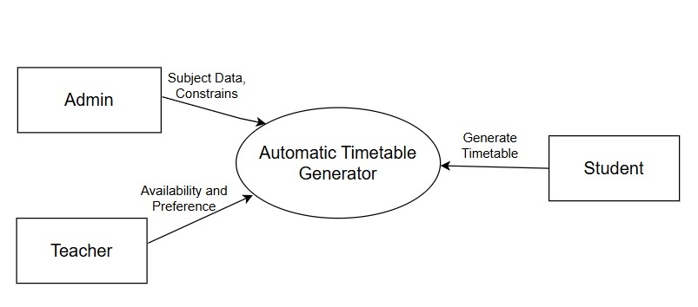
- 1 Level DFD
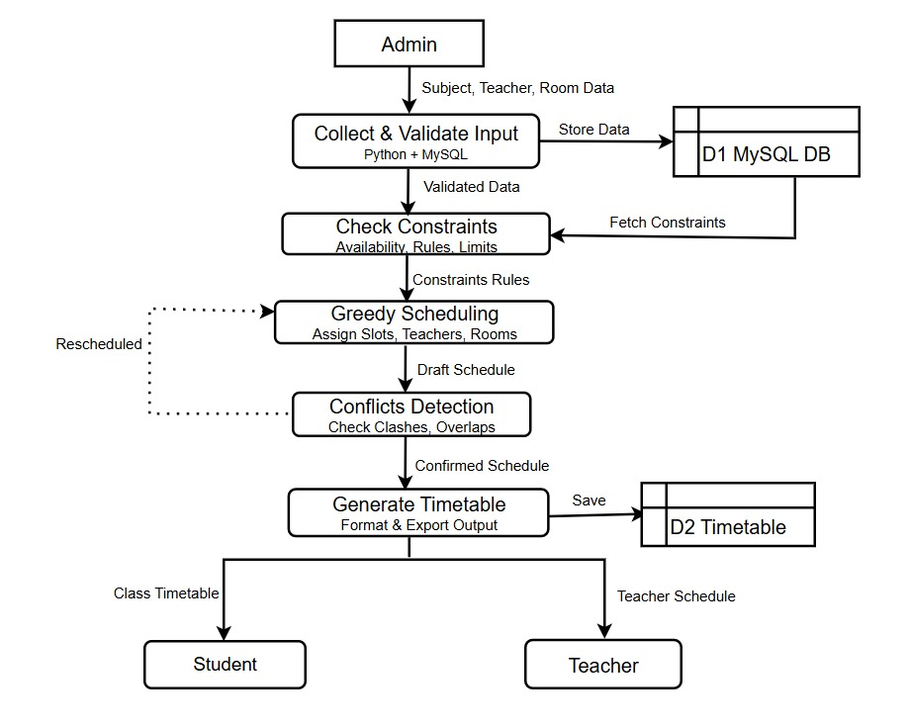

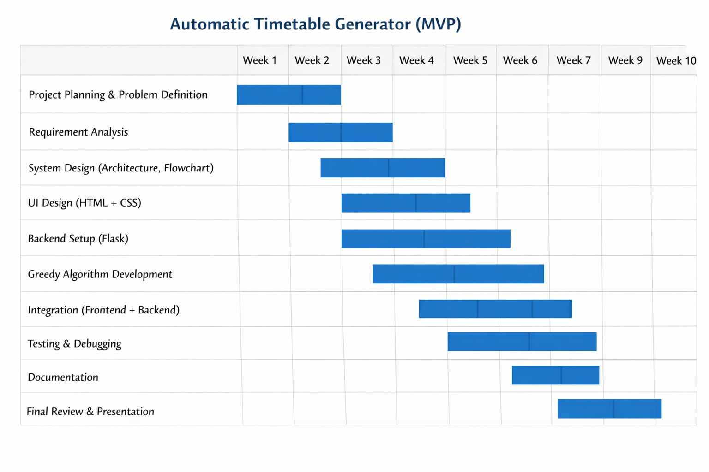
GANTT CHART

PERT CHART
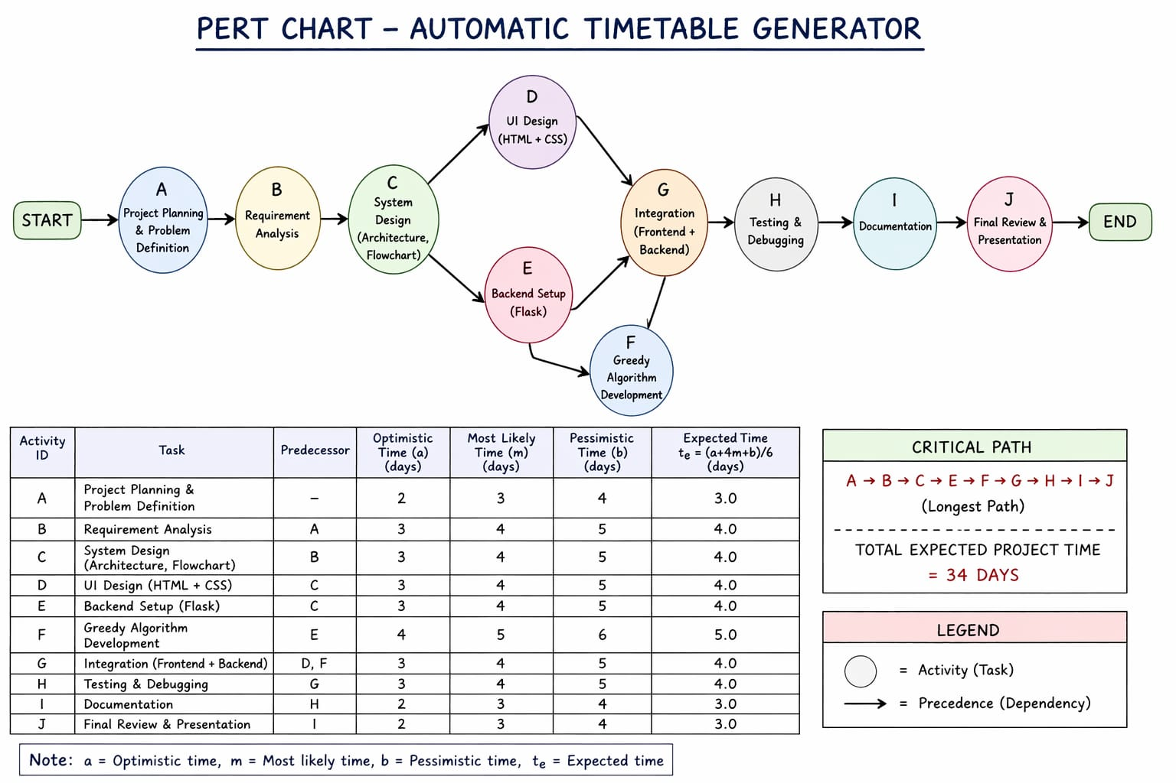

CONTROL FLOW DIAGRAM (CFD)

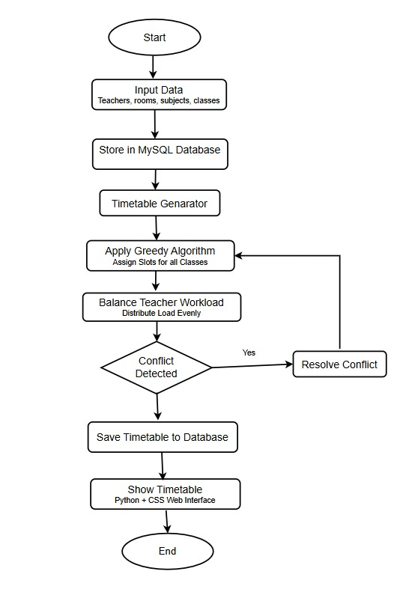

FLOWCHART

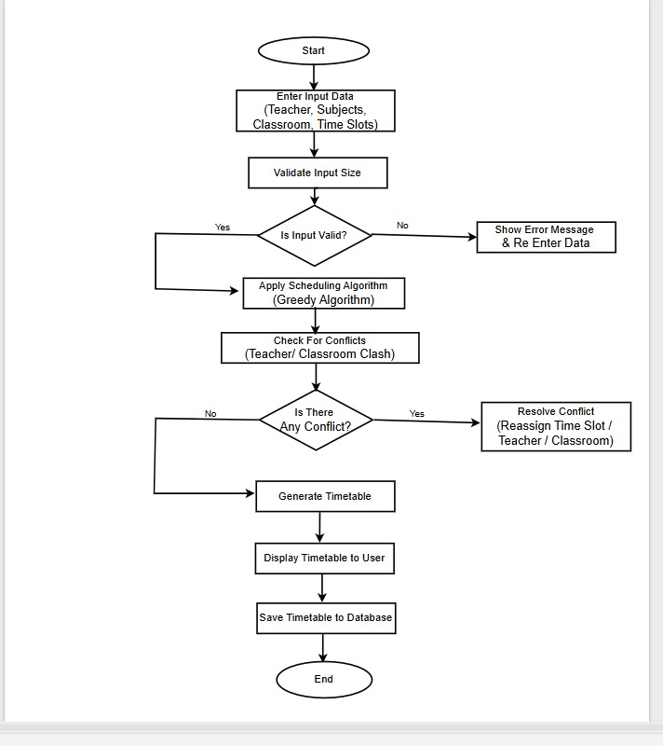

SYSTEM DESIGN

MODULARIZATION DETAILS
The system follows a modular design to ensure scalability, maintainability, and ease of development.
Modules:
1. Frontend Module (View): Handles user interaction through a web interface.
• Login and account creation pages
• Input forms for teachers, subjects, and timetable settings
• Display generated timetables in structured format
• Provides user-friendly navigation using HTML, CSS.
2. Backend Module (Controller): Handles application logic and API communication using Flask.
• Processes user input from frontend
• Validates data (teachers, periods, classes)
• Exposes API endpoints (/generate, /health)
• Sends generated timetable to frontend in JSON format
3. Timetable Generation Module (Logic): Implements core scheduling algorithm using Python.
• Uses random + greedy approach for assignment
• Ensures no teacher conflict across sections
• Handles multi-section timetable generation
• Includes fallback (sequential placement) if random fails
4. Data Handling Module (Model - Basic): Currently handles data in-memory.
• Stores teacher and timetable data temporarily
• Can be extended to database (MySQL) in future
DATA INTEGRITY & CONSTRAINTS
To ensure correctness and reliability of timetable:
• Unique Constraint: Teacher cannot be assigned to multiple sections at the same time
• Validation Check: Number of classes must be between 1–4
• Input Validation: Fields like teacher name, subject, and periods cannot be empty
• Slot Constraint: Total required periods must not exceed available slots
• Consistency: Each timetable slot contains only one subject and teacher
• Conflict Prevention: Teacher schedule tracking ensures no overlap

DATABASE DESIGN (Basic / Future Scope)
Tables:
• Users: id, username, password
• Teachers: id, name, subject, periods per week
• Timetable: id, section, day, period, teacher, subject
Relationships:
• One Teacher → Many Timetable Entries (1:M)
• One Section → Many Timetable Slots (1:M)
USER INTERFACE DESIGN
The system provides a simple web-based interface:
Main Interface:
• Login / Create Account page
• Dashboard for timetable generation
User Flow:
• User logs in or creates an account
• Enters configuration (classes, periods, days)
• Adds teacher and subject details
• Clicks “Generate Timetable”
• System processes and displays timetable
Features in UI:
• Dynamic form inputs for teachers and subjects
• Section-wise timetable display (A, B, C, D)
• Error messages for invalid inputs
• Status messages for generation success/failure
Output Display:
• Timetable shown in tabular format
• Separate tabs for each section
• Clear subject-teacher mapping

TESTING

1. Testing Techniques and Strategies Used
To ensure the correctness, reliability, and efficiency of the Smart Timetable Generator System, multiple testing strategies were employed across both frontend and backend components.
a) Testing Techniques

Black Box Testing
- Focus: Input-output validation without examining internal code structure
- Applied to:
  - User registration form (username, password, confirmation)
  - Login authentication system
  - Teacher addition form (name, subject, periods)
  - Configuration inputs (periods per day, days per week, number of classes)
  - Timetable generation output
  - Section tab switching functionality

White Box Testing
- Focus: Internal logic and code structure validation
- Applied to:
  - Backend functions in app.py:
    - generate_timetable()
    - TimetableGenerator.__init__()
    - TimetableGenerator.generate_timetables()
    - TimetableGenerator._sequential_placement()
  - Frontend functions in script.js:
    - loadAccounts()
    - saveAccounts()
    - createSectionTabs()
    - displayTimetable()

Boundary Value Analysis (BVA)
- Test Cases:
  - Username: Minimum 3 characters (tested: 2, 3, 4 characters)
  - Password: Minimum 4 characters (tested: 3, 4, 5 characters)
  - Number of Classes: Valid range 1-4 (tested: 0, 1, 4, 5)
  - Periods per Day: Valid range 1-10 (tested: 0, 1, 10, 11)
  - Days per Week: Valid range 1-7 (tested: 0, 1, 7, 8)
  - Periods per Week: Minimum 1 (tested: 0, 1, 2)

b) Testing Strategies

Unit Testing
Function-level testing for individual components:
- Frontend Functions:
  - loadAccounts() — Load user accounts from localStorage
  - saveAccounts() — Save accounts to localStorage
  - removeTeacher(id) — Remove teacher from array
  - updateTeachersList() — Update UI with teacher list
  - createSectionTabs() — Generate dynamic section tabs
  - displayTimetable(section) — Render timetable for specific section
- Backend Functions:
  - TimetableGenerator.__init__() — Initialize with proper parameters
  - generate_timetables() — Create conflict-free timetables
  - _sequential_placement() — Fallback placement algorithm
  - validate_timetable() — Check for conflicts

Integration Testing
Testing interaction between multiple components:
- Frontend-Backend Communication:
  - Login → Account validation → Dashboard display
  - Teacher addition → Array update → UI refresh
  - Generate button → API call → Backend processing → Response handling
  - Timetable display → Section selection → Tab switching
- Data Flow Testing:
  - User input → Form validation → localStorage storage
  - Configuration → API request → Backend algorithm → JSON response → UI rendering

System Testing
End-to-end workflow testing:
- Complete User Journey:
  - Account creation → Login → Dashboard
  - Configuration → Teacher addition → Generation → Display
  - Section switching → Logout → Re-login → Persistence check
- Cross-Browser Testing:
  - Chrome, Firefox, Safari, Edge compatibility
  - Mobile responsive design validation

2. Test Reports

a) Unit Test Cases
TC NO. | Function Tested | Input | Expected Output | Result
UT01 | saveAccounts() | Valid user object | Saved to localStorage | Pass ✅
UT02 | loadAccounts() | Existing localStorage data | Array of user accounts | Pass ✅
UT03 | removeTeacher(id) | Teacher ID: 12345 | Teacher removed from array | Pass ✅
UT04 | updateTeachersList() | 3 teachers in array | Display 3 teacher cards | Pass ✅
UT05 | createSectionTabs() | numberOfClasses = 4 | 4 tabs (A, B, C, D) | Pass ✅
UT06 | displayTimetable() | Section 'A' data | HTML table with periods | Pass ✅
UT07 | TimetableGenerator.__init__() | 3 classes, 7 periods, 6 days | Sections: ['A', 'B', 'C'] | Pass ✅
UT08 | generate_timetables() | 5 teachers, 3 sections | 3 timetables without conflicts | Pass ✅
UT09 | _sequential_placement() | Failed random placement | Alternative slot found | Pass ✅
UT10 | Password validation | Password: "abc" (3 chars) | Error: min 4 characters | Pass ✅

SYSTEM SECURITY MEASURES

1. Security Overview
The Smart Timetable Generator implements multiple security layers to protect user data, prevent unauthorized access, and ensure system integrity.
Security Goals
Confidentiality: Protect user credentials and data
Integrity: Ensure data accuracy and prevent tampering
Availability: Maintain system accessibility
Authentication: Verify user identity
Authorization: Control access to resources

2. Authentication & Authorization
2.1 User Authentication
Login System Security:
Case-sensitive username/password matching
Password masking (type="password")
Whitespace trimming to prevent bypass
Generic error messages (don't reveal which field is wrong)

Account Creation Validation:
Username: Minimum 3 characters
Password: Minimum 4 characters
Password confirmation required
Duplicate username prevention
Client-side validation before submission

FUTURE SCOPE AND ENHANCEMENTS

The Automatic Timetable Generator developed in this project provides a basic and efficient solution for generating conflict-free timetables. However, there are several areas where the system can be further enhanced to improve functionality, scalability, and user experience.
1. Integration of Advanced Algorithms (AI/ML)
Currently, the system uses a Greedy/Random approach for timetable generation. In the future:
- Artificial Intelligence and Machine Learning algorithms can be implemented.
- Optimization techniques like Genetic Algorithms or Constraint Satisfaction Problems (CSP) can be used.
- This will help in generating more optimal and intelligent timetables considering multiple constraints.
2. Database Integration (Full Implementation)
- Currently, data is handled in-memory or basic structure.
- Future versions can fully integrate MySQL or cloud databases.
- This will allow:
  - Permanent data storage
  - Better data management
  - Multi-user access
3. Mobile Application Development
- A mobile app (Android/iOS) can be developed.
- Features:
  - View timetable anytime
  - Notifications for schedule changes
  - Easy access for students and teachers
4. Export & Reporting Features
- Add functionality to export timetable as:
  - PDF
  - Excel
- Useful for printing and sharing officially.
5. Real-Time Editing & Updates
- Allow admin to:
  - Modify timetable dynamically
  - Handle sudden changes (teacher absence, room change)
- Real-time updates can be reflected instantly.
6. Cloud Deployment
- Deploy system on cloud platforms (AWS, Azure, etc.)
- Benefits:
  - Global accessibility
  - Better performance
  - Data backup and security
7. Notification System
- Implement notifications via:
  - Email
  - SMS
- Notify users about:
  - Timetable updates
  - Changes or conflicts

CODE
HTML :-
<!DOCTYPE html>
<html lang="en">
<head>
<meta charset="UTF-8">
<meta name="viewport" content="width=device-width, initial-scale=1.0">
<title>Timetable Generator</title>
<link rel="stylesheet" href="styles.css">
</head>
<body>
<!-- Login Page -->
<div id="loginPage" class="page active">
<div class="login-container">
<div class="login-box">
<h1>Timetable Generator</h1>
<h2>Login</h2>
<form id="loginForm">
<div class="form-group">
<label for="username">Username</label>
<input type="text" id="username" required>
</div>
<div class="form-group">
<label for="password">Password</label>
<input type="password" id="password" required>
</div>
<button type="submit" class="btn btn-primary">Login</button>
<div id="loginError" class="error-message"></div>
<div class="create-account-link">
Don't have an account? <a href="#" id="showCreateAccount">Create Account</a>
</div>
</form>
</div>
</div>
</div>
<!-- Create Account Page -->
<div id="createAccountPage" class="page">
<div class="login-container">
<div class="login-box">
<h1>Timetable Generator</h1>
<h2>Create Account</h2>
<form id="createAccountForm">
<div class="form-group">
<label for="newUsername">Username</label>
<input type="text" id="newUsername" required minlength="3">
</div>
<div class="form-group">
<label for="newPassword">Password</label>
<input type="password" id="newPassword" required minlength="4">
</div>
<div class="form-group">
<label for="confirmPassword">Confirm Password</label>
<input type="password" id="confirmPassword" required minlength="4">
</div>
<button type="submit" class="btn btn-primary">Create Account</button>
<div id="createAccountError" class="error-message"></div>
<div id="createAccountSuccess" class="success-message"></div>
<div class="create-account-link">
Already have an account? <a href="#" id="showLogin">Login</a>
</div>
</form>
</div>
</div>
</div>
<!-- Main Application Page -->
<div id="mainPage" class="page">
<nav class="navbar">
<h1>Timetable Generator</h1>
<button id="logoutBtn" class="btn btn-secondary">Logout</button>
</nav>
<div class="container">
<!-- Step 1: Configure Settings -->
<div class="card">
<h2>Step 1: Configure Settings</h2>
<div class="form-row">
<div class="form-group">
<label for="numberOfClasses">Number of Classes/Sections</label>
<select id="numberOfClasses">
<option value="1">1 Class</option>
<option value="2">2 Classes</option>
<option value="3" selected>3 Classes</option>
<option value="4">4 Classes</option>
</select>
</div>
<div class="form-group">
<label for="periodsPerDay">Periods per Day</label>
<input type="number" id="periodsPerDay" min="1" max="10" value="7">
</div>
<div class="form-group">
<label for="daysPerWeek">Days per Week</label>
<input type="number" id="daysPerWeek" min="1" max="7" value="6">
</div>
</div>
</div>
<!-- Step 2: Add Teachers -->
<div class="card">
<h2>Step 2: Add Teachers & Subjects</h2>
<form id="teacherForm">
<div class="form-row">
<div class="form-group">
<label for="teacherName">Teacher Name</label>
<input type="text" id="teacherName" required>
</div>
<div class="form-group">
<label for="subjectName">Subject</label>
<input type="text" id="subjectName" required>
</div>
<div class="form-group">
<label for="periodsPerWeek">Periods per Week</label>
<input type="number" id="periodsPerWeek" min="1" max="20" value="5" required>
</div>
</div>
<button type="submit" class="btn btn-primary">Add Teacher</button>
</form>
<div id="teachersList" class="teachers-list"></div>
</div>
<!-- Step 3: Generate Timetable -->
<div class="card">
<h2>Step 3: Generate Timetable</h2>
<button id="generateBtn" class="btn btn-success">Generate Timetable</button>
<div id="generationStatus" class="status-message"></div>
</div>
<!-- Step 4: View Timetables -->
<div id="timetablesContainer" class="card hidden">
<h2>Generated Timetables</h2>
<div class="section-tabs" id="sectionTabs">
<!-- Tabs will be generated dynamically -->
</div>
<div id="timetableDisplay"></div>
</div>
</div>
</div>
<script src="script.js"></script>
</body>
</html>
CSS :-
* {
margin: 0;
padding: 0;
box-sizing: border-box;
}
body {
font-family: 'Segoe UI', Tahoma, Geneva, Verdana, sans-serif;
background: linear-gradient(135deg, #667eea 0%, #764ba2 100%);
min-height: 100vh;
}
.page {
display: none;
}
.page.active {
display: block;
}
/* Login Page Styles */
.login-container {
display: flex;
justify-content: center;
align-items: center;
min-height: 100vh;
padding: 20px;
}
.login-box {
background: white;
padding: 40px;
border-radius: 10px;
box-shadow: 0 10px 40px rgba(0, 0, 0, 0.2);
width: 100%;
max-width: 400px;
}
.login-box h1 {
color: #667eea;
margin-bottom: 10px;
text-align: center;
}
.login-box h2 {
color: #333;
margin-bottom: 30px;
text-align: center;
font-size: 24px;
}
/* Navbar */
.navbar {
background: white;
padding: 20px 40px;
box-shadow: 0 2px 10px rgba(0, 0, 0, 0.1);
display: flex;
justify-content: space-between;
align-items: center;
}
.navbar h1 {
color: #667eea;
font-size: 24px;
}
/* Container */
.container {
max-width: 1200px;
margin: 40px auto;
padding: 0 20px;
}
/* Card */
.card {
background: white;
padding: 30px;
border-radius: 10px;
box-shadow: 0 5px 20px rgba(0, 0, 0, 0.1);
margin-bottom: 30px;
}
.card h2 {
color: #333;
margin-bottom: 20px;
font-size: 22px;
border-bottom: 2px solid #667eea;
padding-bottom: 10px;
}
/* Form Styles */
.form-group {
margin-bottom: 20px;
}
.form-group label {
display: block;
margin-bottom: 8px;
color: #555;
font-weight: 500;
}
.form-group input,
.form-group select {
width: 100%;
padding: 12px;
border: 2px solid #e0e0e0;
border-radius: 5px;
font-size: 14px;
transition: border-color 0.3s;
}
.form-group input:focus,
.form-group select:focus {
outline: none;
border-color: #667eea;
}
.form-group select {
cursor: pointer;
background: white;
}
.form-row {
display: grid;
grid-template-columns: repeat(auto-fit, minmax(200px, 1fr));
gap: 20px;
margin-bottom: 20px;
}
/* Buttons */
.btn {
padding: 12px 30px;
border: none;
border-radius: 5px;
font-size: 16px;
font-weight: 600;
cursor: pointer;
transition: all 0.3s;
}
.btn-primary {
background: #667eea;
color: white;
}
.btn-primary:hover {
background: #5568d3;
transform: translateY(-2px);
box-shadow: 0 5px 15px rgba(102, 126, 234, 0.4);
}
.btn-secondary {
background: #e0e0e0;
color: #333;
}
.btn-secondary:hover {
background: #d0d0d0;
}
.btn-success {
background: #28a745;
color: white;
width: 100%;
padding: 15px;
font-size: 18px;
}
.btn-success:hover {
background: #218838;
transform: translateY(-2px);
box-shadow: 0 5px 15px rgba(40, 167, 69, 0.4);
}
.btn-danger {
background: #dc3545;
color: white;
padding: 8px 15px;
font-size: 14px;
}
.btn-danger:hover {
background: #c82333;
}
/* Teachers List */
.teachers-list {
margin-top: 20px;
}
.teacher-item {
background: #f8f9fa;
padding: 15px;
border-radius: 5px;
margin-bottom: 10px;
display: flex;
justify-content: space-between;
align-items: center;
border-left: 4px solid #667eea;
}
.teacher-info {
flex: 1;
}
.teacher-info strong {
color: #333;
font-size: 16px;
}
.teacher-info span {
color: #666;
margin-left: 15px;
}
/* Messages */
.error-message {
color: #dc3545;
margin-top: 10px;
font-size: 14px;
}
.success-message {
color: #28a745;
margin-top: 10px;
font-size: 14px;
font-weight: 500;
}
.create-account-link {
text-align: center;
margin-top: 20px;
color: #666;
font-size: 14px;
}
.create-account-link a {
color: #667eea;
text-decoration: none;
font-weight: 600;
}
.create-account-link a:hover {
text-decoration: underline;
}
.status-message {
margin-top: 20px;
padding: 15px;
border-radius: 5px;
font-weight: 500;
}
.status-message.success {
background: #d4edda;
color: #155724;
border: 1px solid #c3e6cb;
}
.status-message.error {
background: #f8d7da;
color: #721c24;
border: 1px solid #f5c6cb;
}
.status-message.loading {
background: #d1ecf1;
color: #0c5460;
border: 1px solid #bee5eb;
}
/* Section Tabs */
.section-tabs {
display: flex;
gap: 10px;
margin-bottom: 20px;
}
.tab-btn {
padding: 10px 20px;
border: 2px solid #667eea;
background: white;
color: #667eea;
border-radius: 5px;
cursor: pointer;
font-weight: 600;
transition: all 0.3s;
}
.tab-btn:hover {
background: #f0f0f0;
}
.tab-btn.active {
background: #667eea;
color: white;
}
/* Timetable Display */
.timetable {
overflow-x: auto;
margin-top: 20px;
}
.timetable table {
width: 100%;
border-collapse: collapse;
background: white;
box-shadow: 0 2px 10px rgba(0, 0, 0, 0.1);
}
.timetable th {
background: #667eea;
color: white;
padding: 15px;
text-align: center;
font-weight: 600;
border: 1px solid #5568d3;
}
.timetable td {
padding: 15px;
text-align: center;
border: 1px solid #e0e0e0;
}
.timetable tr:nth-child(even) {
background: #f8f9fa;
}
.timetable tr:hover {
background: #e9ecef;
}
.period-cell {
min-width: 120px;
}
.subject {
font-weight: 600;
color: #333;
display: block;
}
.teacher {
font-size: 12px;
color: #666;
display: block;
margin-top: 5px;
}
/* Hidden class */
.hidden {
display: none !important;
}
/* Responsive Design */
@media (max-width: 768px) {
.navbar {
padding: 15px 20px;
}
.navbar h1 {
font-size: 18px;
}
.container {
margin: 20px auto;
padding: 0 10px;
}
.card {
padding: 20px;
}
.form-row {
grid-template-columns: 1fr;
}
.teacher-item {
flex-direction: column;
align-items: flex-start;
gap: 10px;
}
.section-tabs {
flex-direction: column;
}
.tab-btn {
width: 100%;
}
.timetable {
font-size: 12px;
}
.timetable th,
.timetable td {
padding: 8px;
}
}

JavaScript :-
// Global variables
let teachers = [];
let timetables = {};
let currentSection = 'A';
let userAccounts = [
{ username: 'Aryan', password: '1234' } // Default account
];
let numberOfClasses = 3; // Default to 3 classes
// DOM Elements
const loginPage = document.getElementById('loginPage');
const createAccountPage = document.getElementById('createAccountPage');
const mainPage = document.getElementById('mainPage');
const loginForm = document.getElementById('loginForm');
const createAccountForm = document.getElementById('createAccountForm');
const loginError = document.getElementById('loginError');
const createAccountError = document.getElementById('createAccountError');
const createAccountSuccess = document.getElementById('createAccountSuccess');
const showCreateAccountLink = document.getElementById('showCreateAccount');
const showLoginLink = document.getElementById('showLogin');
const logoutBtn = document.getElementById('logoutBtn');
const teacherForm = document.getElementById('teacherForm');
const teachersList = document.getElementById('teachersList');
const generateBtn = document.getElementById('generateBtn');
const generationStatus = document.getElementById('generationStatus');
const timetablesContainer = document.getElementById('timetablesContainer');
const timetableDisplay = document.getElementById('timetableDisplay');
const sectionTabs = document.getElementById('sectionTabs');
const numberOfClassesSelect = document.getElementById('numberOfClasses');
// Load accounts from localStorage
function loadAccounts() {
const saved = localStorage.getItem('timetableAccounts');
if (saved) {
userAccounts = JSON.parse(saved);
// Ensure default account exists
if (!userAccounts.find(acc => acc.username === 'Aryan')) {
userAccounts.unshift({ username: 'Aryan', password: '1234' });
}
}
}
// Save accounts to localStorage
function saveAccounts() {
localStorage.setItem('timetableAccounts', JSON.stringify(userAccounts));
}
// Initialize
loadAccounts();
// Show create account page
showCreateAccountLink.addEventListener('click', (e) => {
e.preventDefault();
loginPage.classList.remove('active');
createAccountPage.classList.add('active');
createAccountForm.reset();
createAccountError.textContent = '';
createAccountSuccess.textContent = '';
});
// Show login page
showLoginLink.addEventListener('click', (e) => {
e.preventDefault();
createAccountPage.classList.remove('active');
loginPage.classList.add('active');
loginForm.reset();
loginError.textContent = '';
});
// Create account functionality
createAccountForm.addEventListener('submit', (e) => {
e.preventDefault();
const username = document.getElementById('newUsername').value.trim();
const password = document.getElementById('newPassword').value;
const confirmPassword = document.getElementById('confirmPassword').value;
// Clear previous messages
createAccountError.textContent = '';
createAccountSuccess.textContent = '';
// Validation
if (username.length < 3) {
createAccountError.textContent = 'Username must be at least 3 characters long';
return;
}
if (password.length < 4) {
createAccountError.textContent = 'Password must be at least 4 characters long';
return;
}
if (password !== confirmPassword) {
createAccountError.textContent = 'Passwords do not match';
return;
}
// Check if username already exists
if (userAccounts.find(acc => acc.username === username)) {
createAccountError.textContent = 'Username already exists';
return;
}
// Create account
userAccounts.push({ username, password });
saveAccounts();
createAccountSuccess.textContent = 'Account created successfully! Redirecting to login...';
setTimeout(() => {
createAccountPage.classList.remove('active');
loginPage.classList.add('active');
createAccountForm.reset();
createAccountSuccess.textContent = '';
}, 2000);
});
// Login functionality
loginForm.addEventListener('submit', (e) => {
e.preventDefault();
const username = document.getElementById('username').value.trim();
const password = document.getElementById('password').value;
const account = userAccounts.find(acc => acc.username === username && acc.password === password);
if (account) {
loginPage.classList.remove('active');
mainPage.classList.add('active');
loginError.textContent = '';
} else {
loginError.textContent = 'Invalid username or password';
}
});
// Logout functionality
logoutBtn.addEventListener('click', () => {
mainPage.classList.remove('active');
loginPage.classList.add('active');
document.getElementById('username').value = '';
document.getElementById('password').value = '';
loginError.textContent = '';
// Reset teachers and timetables
teachers = [];
timetables = {};
updateTeachersList();
timetablesContainer.classList.add('hidden');
});
// Number of classes change handler
numberOfClassesSelect.addEventListener('change', () => {
numberOfClasses = parseInt(numberOfClassesSelect.value);
});
// Add teacher functionality
teacherForm.addEventListener('submit', (e) => {
e.preventDefault();
const teacherName = document.getElementById('teacherName').value.trim();
const subjectName = document.getElementById('subjectName').value.trim();
const periodsPerWeek = parseInt(document.getElementById('periodsPerWeek').value);
if (teacherName && subjectName && periodsPerWeek > 0) {
teachers.push({
id: Date.now(),
name: teacherName,
subject: subjectName,
periodsPerWeek: periodsPerWeek
});
updateTeachersList();
teacherForm.reset();
}
});
// Update teachers list display
function updateTeachersList() {
if (teachers.length === 0) {
teachersList.innerHTML = '<p style="color: #999; text-align: center;">No teachers added yet</p>';
return;
}
teachersList.innerHTML = teachers.map(teacher => `
<div class="teacher-item">
<div class="teacher-info">
<strong>${teacher.name}</strong>
<span>Subject: ${teacher.subject}</span>
<span>Periods/Week: ${teacher.periodsPerWeek}</span>
</div>
<button class="btn btn-danger" onclick="removeTeacher(${teacher.id})">Remove</button>
</div>
`).join('');
}
// Remove teacher
function removeTeacher(id) {
teachers = teachers.filter(t => t.id !== id);
updateTeachersList();
}
// Generate timetable
generateBtn.addEventListener('click', async () => {
if (teachers.length === 0) {
showStatus('Please add at least one teacher before generating timetable', 'error');
return;
}
const periodsPerDay = parseInt(document.getElementById('periodsPerDay').value);
const daysPerWeek = parseInt(document.getElementById('daysPerWeek').value);
numberOfClasses = parseInt(numberOfClassesSelect.value);
showStatus('Generating timetables...', 'loading');
try {
const response = await fetch('http://localhost:5000/generate', {
method: 'POST',
headers: {
'Content-Type': 'application/json'
},
body: JSON.stringify({
teachers: teachers,
periodsPerDay: periodsPerDay,
daysPerWeek: daysPerWeek,
numberOfClasses: numberOfClasses
})
});
const data = await response.json();
if (data.success) {
timetables = data.timetables;
showStatus('Timetables generated successfully!', 'success');
createSectionTabs();
displayTimetable(Object.keys(timetables)[0]); // Display first section
timetablesContainer.classList.remove('hidden');
} else {
showStatus(data.message || 'Failed to generate timetable', 'error');
}
} catch (error) {
showStatus('Error: Make sure the Python backend is running on port 5000', 'error');
console.error('Error:', error);
}
});
// Show status message
function showStatus(message, type) {
generationStatus.textContent = message;
generationStatus.className = `status-message ${type}`;
}
// Create section tabs dynamically
function createSectionTabs() {
const sectionNames = ['A', 'B', 'C', 'D'];
sectionTabs.innerHTML = '';
Object.keys(timetables).forEach((section, index) => {
const btn = document.createElement('button');
btn.className = `tab-btn ${index === 0 ? 'active' : ''}`;
btn.dataset.section = section;
btn.textContent = `Section ${section}`;
btn.addEventListener('click', () => {
document.querySelectorAll('.tab-btn').forEach(b => b.classList.remove('active'));
btn.classList.add('active');
displayTimetable(section);
});
sectionTabs.appendChild(btn);
});
}
// Section tab switching (kept for reference, now handled in createSectionTabs)
// This is now redundant but keeping structure for compatibility
/*
tabBtns.forEach(btn => {
btn.addEventListener('click', () => {
tabBtns.forEach(b => b.classList.remove('active'));
btn.classList.add('active');
const section = btn.dataset.section;
displayTimetable(section);
});
});
*/
// Display timetable
function displayTimetable(section) {
currentSection = section;
const timetable = timetables[section];
if (!timetable) {
timetableDisplay.innerHTML = '<p>No timetable available for this section</p>';
return;
}
const days = ['Monday', 'Tuesday', 'Wednesday', 'Thursday', 'Friday', 'Saturday', 'Sunday'];
const daysPerWeek = parseInt(document.getElementById('daysPerWeek').value);
const periodsPerDay = parseInt(document.getElementById('periodsPerDay').value);
let html = `
<div class="timetable">
<table>
<thead>
<tr>
<th>Day/Period</th>
${Array.from({length: periodsPerDay}, (_, i) => `<th>Period ${i + 1}</th>`).join('')}
</tr>
</thead>
<tbody>
`;
for (let day = 0; day < daysPerWeek; day++) {
html += `<tr><td><strong>${days[day]}</strong></td>`;
for (let period = 0; period < periodsPerDay; period++) {
const slot = timetable[day][period];
if (slot) {
html += `
<td class="period-cell">
<span class="subject">${slot.subject}</span>
<span class="teacher">${slot.teacher}</span>
</td>
`;
} else {
html += `<td class="period-cell">-</td>`;
}
}
html += `</tr>`;
}
html += `
</tbody>
</table>
</div>
`;
timetableDisplay.innerHTML = html;
}
// Initialize
updateTeachersList();

Python (Flask) :-
from flask import Flask, request, jsonify
from flask_cors import CORS
import random
from typing import List, Dict, Tuple
app = Flask(__name__)
CORS(app) # Enable CORS for frontend communication
class TimetableGenerator:
def __init__(self, teachers: List[Dict], periods_per_day: int, days_per_week: int, number_of_classes: int = 3):
self.teachers = teachers
self.periods_per_day = periods_per_day
self.days_per_week = days_per_week
self.number_of_classes = number_of_classes
self.sections = ['A', 'B', 'C', 'D'][:number_of_classes] # Dynamic sections based on input
def generate_timetables(self) -> Dict:
"""Generate timetables for all sections"""
timetables = {}
# Initialize timetables for each section
for section in self.sections:
timetables[section] = [[None for _ in range(self.periods_per_day)]
for _ in range(self.days_per_week)]
# Track teacher assignments to prevent conflicts
teacher_schedule = {} # {(day, period): {teacher_name: section}}
# Create a list of all assignments needed
assignments = []
for teacher in self.teachers:
for _ in range(teacher['periodsPerWeek']):
for section in self.sections:
assignments.append({
'teacher': teacher['name'],
'subject': teacher['subject'],
'section': section
})
# Shuffle assignments for randomness
random.shuffle(assignments)
# Try to assign each period
for assignment in assignments:
placed = False
attempts = 0
max_attempts = 100
while not placed and attempts < max_attempts:
day = random.randint(0, self.days_per_week - 1)
period = random.randint(0, self.periods_per_day - 1)
section = assignment['section']
teacher = assignment['teacher']
# Check if this slot is free for the section
if timetables[section][day][period] is None:
# Check if teacher is not already assigned at this time
slot_key = (day, period)
if slot_key not in teacher_schedule:
teacher_schedule[slot_key] = {}
if teacher not in teacher_schedule[slot_key]:
# Assign the period
timetables[section][day][period] = {
'teacher': teacher,
'subject': assignment['subject']
}
teacher_schedule[slot_key][teacher] = section
placed = True
attempts += 1
if not placed:
# If we couldn't place it after many attempts, try sequential placement
placed = self._sequential_placement(
timetables, teacher_schedule, assignment
)
return timetables
def _sequential_placement(self, timetables, teacher_schedule, assignment):
"""Try to place assignment sequentially if random placement fails"""
section = assignment['section']
teacher = assignment['teacher']
for day in range(self.days_per_week):
for period in range(self.periods_per_day):
if timetables[section][day][period] is None:
slot_key = (day, period)
if slot_key not in teacher_schedule:
teacher_schedule[slot_key] = {}
if teacher not in teacher_schedule[slot_key]:
timetables[section][day][period] = {
'teacher': teacher,
'subject': assignment['subject']
}
teacher_schedule[slot_key][teacher] = section
return True
return False
def validate_timetable(self, timetables: Dict, teacher_schedule: Dict) -> bool:
"""Validate that there are no conflicts in the generated timetable"""
# Check for teacher conflicts (teacher teaching multiple sections at same time)
for slot_key, teachers in teacher_schedule.items():
teacher_sections = {}
for teacher, section in teachers.items():
if teacher in teacher_sections:
return False # Teacher conflict found
teacher_sections[teacher] = section
return True
@app.route('/generate', methods=['POST'])
def generate_timetable():
"""API endpoint to generate timetable"""
try:
data = request.json
teachers = data.get('teachers', [])
periods_per_day = data.get('periodsPerDay', 7)
days_per_week = data.get('daysPerWeek', 6)
number_of_classes = data.get('numberOfClasses', 3)
if not teachers:
return jsonify({
'success': False,
'message': 'No teachers provided'
}), 400
# Validate number of classes
if number_of_classes < 1 or number_of_classes > 4:
return jsonify({
'success': False,
'message': 'Number of classes must be between 1 and 4'
}), 400
# Validate total periods
total_slots = periods_per_day * days_per_week
total_required = sum(t['periodsPerWeek'] for t in teachers)
if total_required > total_slots:
return jsonify({
'success': False,
'message': f'Not enough slots! Required: {total_required}, Available: {total_slots}'
}), 400
# Generate timetable
generator = TimetableGenerator(teachers, periods_per_day, days_per_week, number_of_classes)
timetables = generator.generate_timetables()
return jsonify({
'success': True,
'timetables': timetables,
'message': 'Timetable generated successfully'
})
except Exception as e:
return jsonify({
'success': False,
'message': f'Error generating timetable: {str(e)}'
}), 500
@app.route('/health', methods=['GET'])
def health_check():
"""Health check endpoint"""
return jsonify({'status': 'healthy', 'message': 'Timetable Generator API is running'})
if __name__ == '__main__':
print("Starting Timetable Generator Backend...")
print("Server running on http://localhost:5000")
print("Press Ctrl+C to stop the server")
app.run(debug=True, host='0.0.0.0', port=5000)

SNAPSHOTS

Frontend :-
Login Page :-
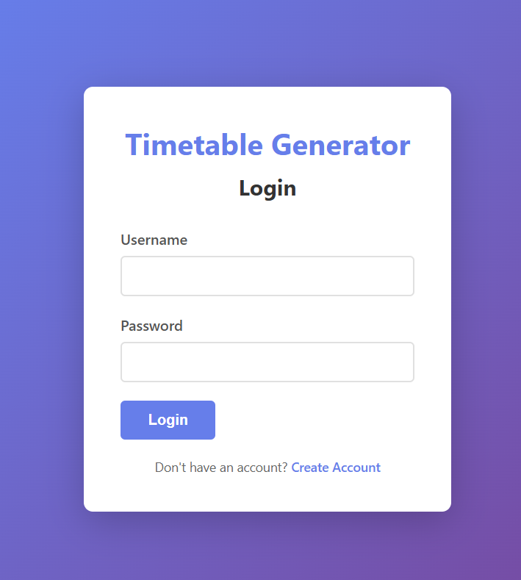
Create Account Page:-
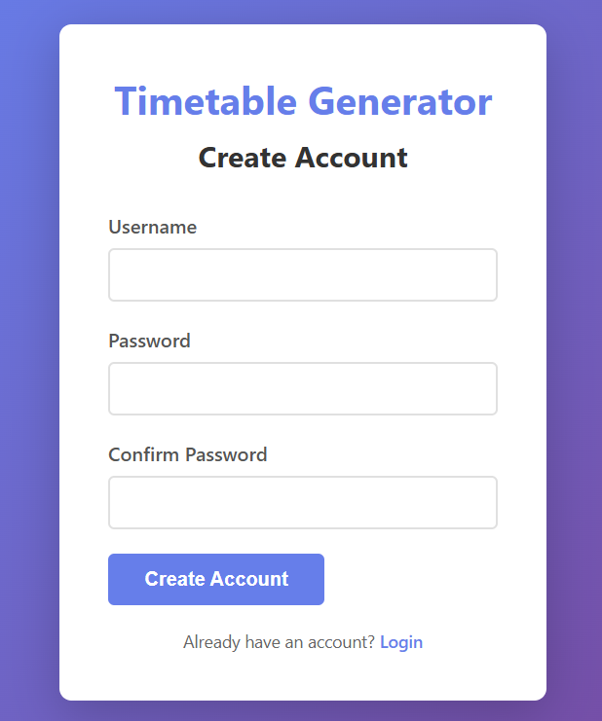

Configure setting:-
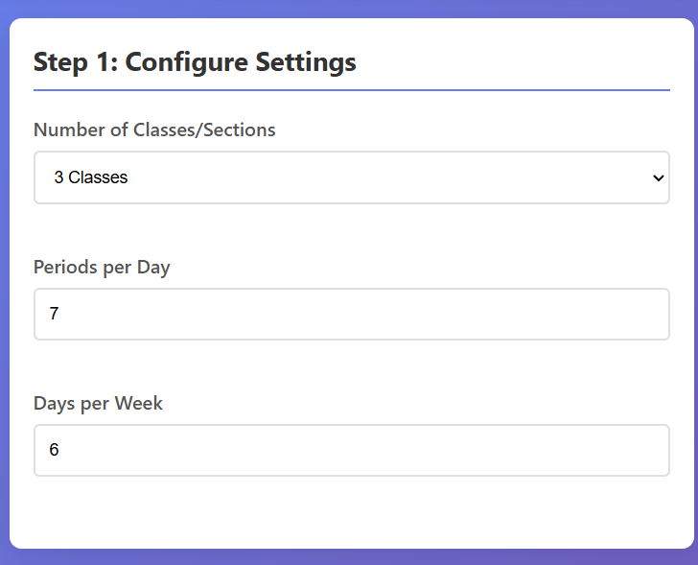
Number of classes for the generation of TimeTable :-
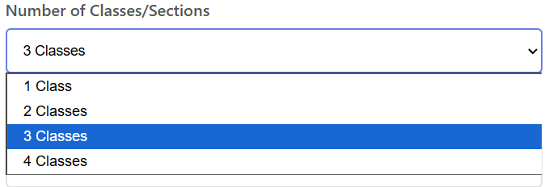

Teachers and their subjects adding in database:-
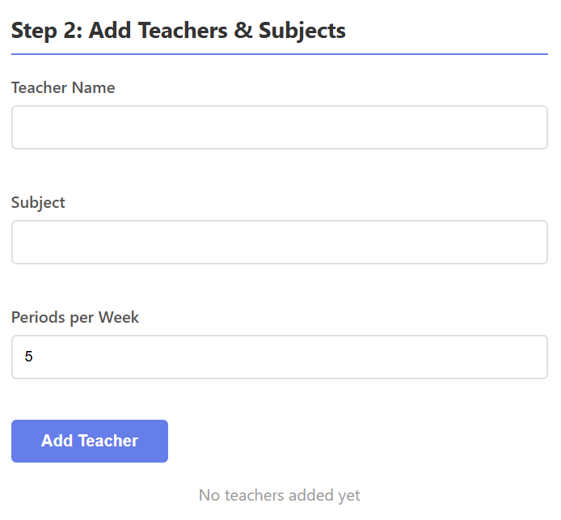

Generation Button:-
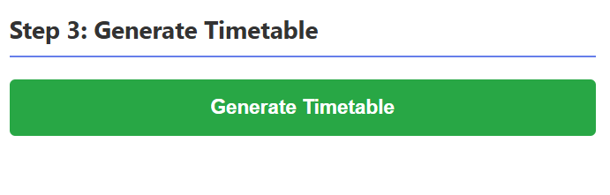
Backend:-
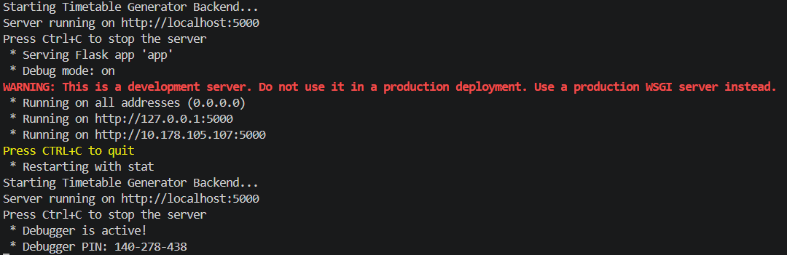

Working: -
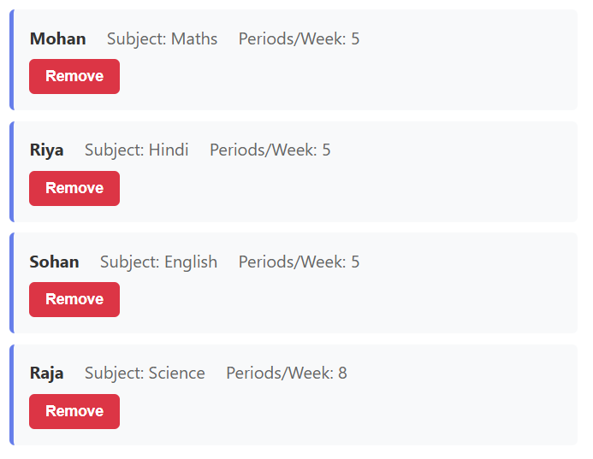
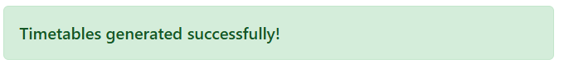
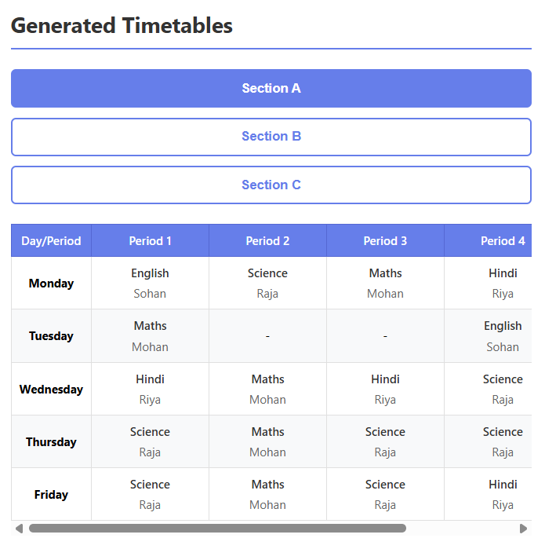

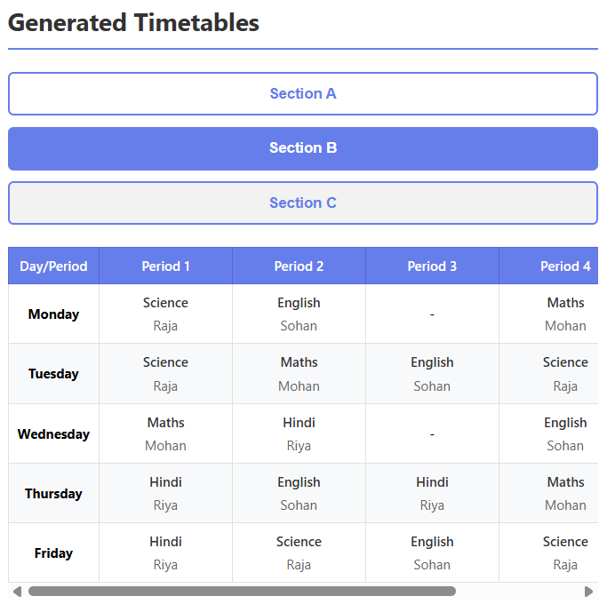

BIBLIOGRAPHY

- Ian Sommerville, Software Engineering, 10th Edition, Pearson Education, 2016.
- Thomas H. Cormen, Charles E. Leiserson, Ronald L. Rivest, and Clifford Stein, Introduction to Algorithms, 3rd Edition, MIT Press, 2009.
- Herbert Schildt, Python: The Complete Reference, McGraw-Hill Education.
- Ramez Elmasri and Shamkant B. Navathe, Fundamentals of Database Systems, Pearson Education, 2015.
- Python Software Foundation, Python Documentation.
- Flask Documentation.
- Oracle Corporation, MySQL Reference Manual.
- Mozilla, MDN Web Documentation for HTML, CSS, and JavaScript.
- Research Paper: “Automated Timetable Generation Using Genetic Algorithms”, International Journal of Computer Applications (IJCA).

